Marinas: Best Management Practices & Water Quality
Prepared for GA DNR – Coastal Resources Division

Janice Flory and Merryl Alber

February 2005

Overview

This document provides an introduction to the Best Management Practices associated with the development of marinas. Part A is focused specifically on water quality and describes the types of measurements EPA recommends for marinas. Part B is an overview of the EPA Best Management Practices for all aspects of marina construction and management. Part C provides information on some of the criteria that other states use with regard to marinas. At the end of the document is a list of Resource documents and websites with useful information on marinas, and an Appendix with information on volunteer water quality monitoring programs in marinas.

Part A. US EPA Guidance on Water Quality Assessment

US EPA provided information on marinas in Guidance Specifying Management Measures for Sources of Nonpoint Pollution in Coastal Waters -- Chapter 5: Management Measure for Marinas and Recreational Boating (US EPA 1993) (http://www.epa.gov/OWOW/NPS/MMGI/index.html). The technical information in this document was expanded upon (but not supplanted by) a 2001 publication, EPA National Management Measures to Control Nonpoint Source Pollution from Marinas and Recreational Boating (http://www.epa.gov/owow/nps/mmsp/index.html). What follows is a summary of the information in these two documents with regard to water quality.

A marina's location on the water's edge makes it susceptible to upstream inputs of non-point pollutants from the watershed, so not all observations of pollutants in a marina were generated there. EPA (2001) lists the following pollutants as those that might be generated at the marina itself: nutrients and pathogens (from pet waste and overboard sewage discharge), sediments (from parking lot runoff and shoreline erosion), fish waste (from dockside fish cleaning and overboard dumping), petroleum hydrocarbons (from fuel and oil drippings and spills and from solvents), toxic metals (from antifoulants and hull and boat maintenance debris), and liquid and solid wastes (from engine and hull maintenance and general marina activities). Of these various pollutants, decreases in dissolved oxygen and increases in metals and hydrocarbons were given as priority water quality parameters for observation.

The guidance on best management practices specifies that water quality be considered in the siting and design of marinas. “In areas of known good water quality, monitoring might not be needed for small marina developments. The BMPs described here are useful for major developments or expansions so that sufficient water quality measurements are made at a site to ensure that existing conditions are not significantly altered.” (US EPA 2001, section 4-2). They include:

a. Perform preconstruction inspection and assessment.
b. Use a water quality modeling methodology to predict postconstruction water quality conditions.
 c. Monitor water quality using indicators (note that this is "universally recommended" in Table 4-2, below).
d. Use rapid bioassessment techniques to monitor water quality.
e.  Establish a volunteer monitoring program (see Appendix 1).

A summary of the costs and benefits associated with these measures is provided below.
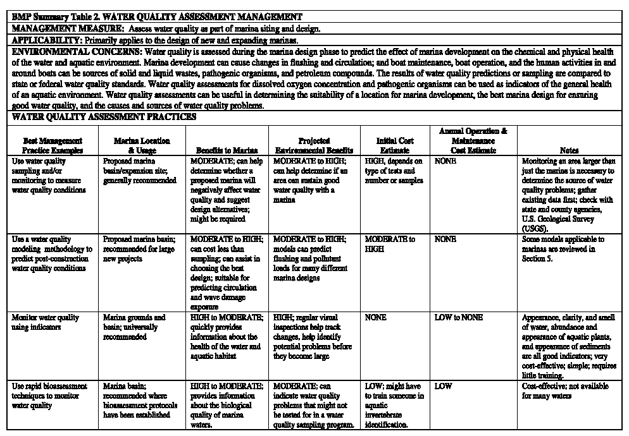
(con’t)
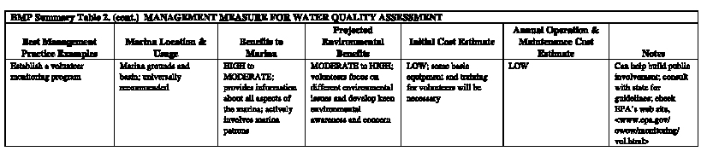
US EPA, 2001 Section 4

The first step in a marina water quality assessment should be the evaluation and the characterization of existing water quality conditions. Before an analysis of the potential impacts of future development is made, it should be determined whether current water quality is acceptable, marginal, or substandard. The main objective of a preconstruction sampling program is to characterize the water surrounding the area in the vicinity of the proposed marina. In the absence of existing data from academic or government institutions, the best way to assess existing water quality is to measure it. Preconstruction sampling can also provide necessary information for modeling investigations.

EPA describes both monitoring and modeling as means for tracking and predicting water quality effects from marina operations. "Trend monitoring is conducted to establish seasonal and long-term trends in water quality. Trend sampling may take place on a biweekly or monthly basis for a year at a time. Stations should be sampled at a consistent phase of the tide and time of day to minimize tidal and diurnal influences on water quality variations. Some stations may be selected for more detailed evaluation during the intensive survey. Long-term trend monitoring should also be considered as a way to track changes in water quality between the intensive surveys." (US EPA 2001, Section 5) It was noted that in some areas, volunteer organizations may be interested in water quality monitoring opportunities (see Appendix).

For large new projects, EPA recommends a water quality _modeling_ methodology to predict post-construction water quality conditions. The suggested list of water quality sampling measures necessary for modeling efforts is as follows (US EPA 2001, Section 5):

- Dissolved nutrients (nitrate, nitrite, ammonium, organic nitrogen, phosphate)
- Dissolved oxygen (and related measures of sediment oxygen demand, 5-day biological oxygen demand, and total organic carbon)
- Chlorophyll a (or algal dry weight)
- Fecal coliform
- Physical properties (salinity, temperature, light extinction coefficients [Secchi depth], water body dimensions, and flow characteristics).

The guidance also suggests the need for broad spatial coverage, although the frequency of sampling depends on the model used. Note that this includes areas beyond the influence of the marina, which can be used as a control. Regardless of model type, EPA recommends:

- Hourly studies covering at least 4 full tidal cycles at boundary stations and those directly adjacent to the marina impacts
- Measurements of tide, current velocity, salinity, dissolved oxygen, fecal coliform, nitrogen, and phosphorus
- An assessment of point source waste loads in the area prior to the survey
In terms of dissolved oxygen, it was described as “especially important” to get at least 24-hour data, since WQ standards usually include reference to the daily minimum. Also, if the water body is stratified, it is important to collect surface, mid-depth (above and below the pycno- and thermocline, if possible), and bottom waters. “A primary objective for use of a water quality assessment is to ensure that the 24-hour average dissolved oxygen concentration and the 1-hour (or instantaneous) minimum dissolved oxygen concentration both inside the proposed marina and in adjacent ambient waters will not violate State water quality standards or preclude designated uses…In most States, the water quality is graded based on DO content, and a standard exists for the 24-hour average concentration and an instantaneous minimum concentration. A State's water quality standard for DO during the critical season may be used to set limits of acceptability for good water quality.” (US EPA 1993, Section B)

“If a model is being developed, sediment oxygen demand and other data that may be used to estimate dissolved oxygen levels using numerical modeling procedures should be collected during the sampling program. A postdevelopment field program may include dye-release and/or drogue-release studies (to verify circulation patterns) and a water quality monitoring program. Data collected from such studies may be used to assist in the prediction of water quality or circulation at other potential marina sites. ” (US EPA 1993, Section B)

Part B. Best Management Practices for Marinas

There are numerous management measures associated with marinas that can help to reduce coastal non-point pollution. In Section 6217 of the Coastal Zone Act Reauthorization Amendments of 1990 (CZARA), management measures are defined as "economically achievable measures to control the addition of pollutants to our coastal waters, which reflect the greatest degree of pollutant reduction achievable through the application of the best available nonpoint pollution control practices, technologies, processes, siting criteria, operating methods, or other alternatives. These management measures will be incorporated by States into their coastal nonpoint programs, which under CZARA are to provide for the implementation of management measures that are "in conformity" with this guidance.”
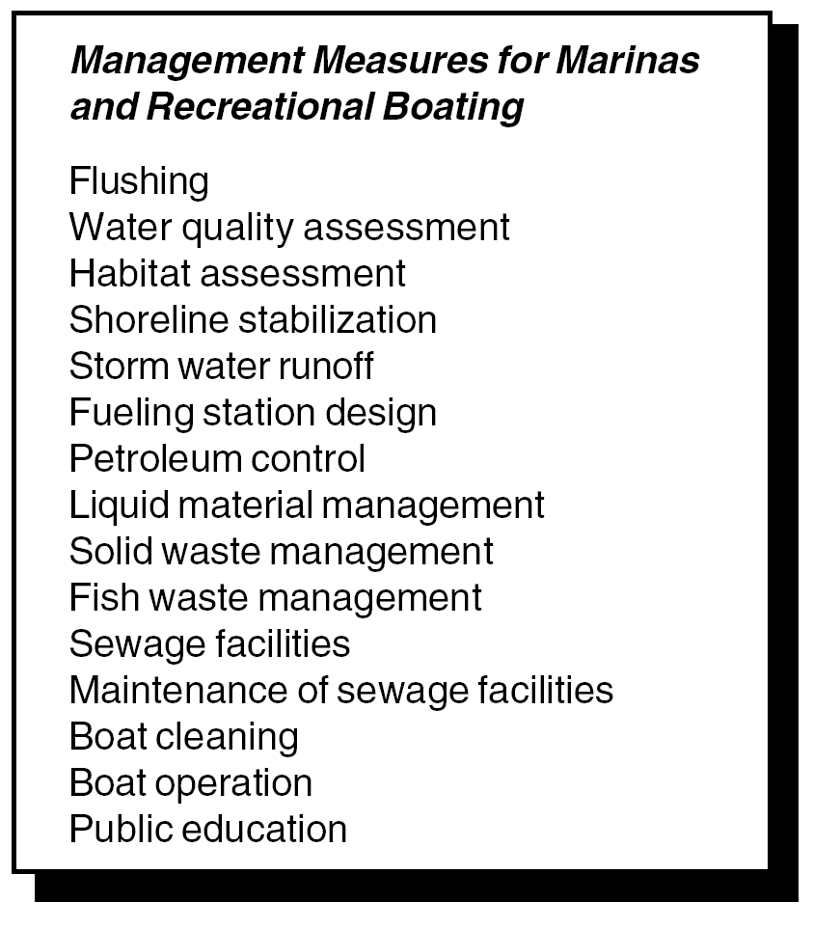

Chapter 5 in the EPA 1993 guidance document on non-point pollution (US EPA 1993) provides information on specific management measures “to protect coastal waters from sources of nonpoint pollution from marinas and recreational boating.” The document included management measures for 15 separate topics (see list at right, from US EPA 2001). More information on these measures is available as Appendix A in the EPA 2001 document (EPA National Management Measures to Control Nonpoint Source Pollution from Marinas and Recreational Boating). What follows below was compiled from both documents.

MANAGEMENT MEASURES
MARINA FLUSHING -- The measure requires that marina siting and design allow for maximum flushing of the water supply for the site via tides and/or currents. Adequate flushing renews the water and reduces the potential for the stagnation of water in a marina. This helps to maintain the biological productivity and reduce the potential for toxic accumulation in bottom sediment. BMPs include:

a. Site and design new marinas such that the bottom of the marina and the entrance channel are not deeper than adjacent navigable water unless it can be demonstrated that the bottom will support a natural population of benthic organisms.
b. Design new marinas with as few enclosed water sections or separated basins as possible to promote circulation within the entire basin
c. Consider other design alternatives in poorly flushed waterbodies (open marina basin over semi-enclosed design; wave attenuators instead of fixed breakwaters) to enhance flushing.
d. Consider the value of entrance channels in promoting flushing when designing or reconfiguring a marina.
e. Establish two openings at the most appropriate locations within the marina to promote flow-through currents (i.e. at opposite ends of the marina).
f. Designate areas that are and are not suitable for marina development; i.e., provide advance identification of waterbodies that do and do not experience flushing adequate for marina development.
g. Consider mechanical aerators to improve flushing and water quality where basin and entrance channel configuration cannot provide adequate flushing.

WATER QUALITY ASSESSMENT -- This measure specifies that water quality be considered in the siting and design of both new and expanding marinas. (BMPs are listed below for completeness, but is discussed in more detail in the main document)

a. Perform preconstruction inspection and assessment
b. Use a water quality modeling methodology to predict postconstruction water quality conditions.
c.  Monitor water quality using indicators.
d. Use rapid bioassessment techniques to monitor water quality
e.  Establish a volunteer monitoring program.

HABITAT ASSESSMENT -- Marinas should be designed and located so as to protect against adverse impacts on shellfish resources, wetlands, submerged aquatic vegetation, and other important habitat areas as designated by local, state, or federal governments. BMPS include:

a. Conduct habitat surveys and characterize the marina site, including identifying any exotic or invasive species.
b. Use rapid bioassessment techniques to assess effects on biological resources.
c. Assess historic habitat function (e.g., spawning area, nursery area, migration pathway) to minimize indirect effects.
d. Create new habitats or expand habitats in the marina basin.
e. Minimize disturbance to indigenous vegetation in the riparian area.
f. Use dry stack storage.
g. Consider alternative sites where adverse environmental effects will be minimized or positive effects will be maximized.
h. Redevelop waterfront sites that have been previously disturbed and expand existing marinas.
i. Develop a marina siting policy to discourage development in areas containing important habitat as designated by local, State, or Federal agencies.

SHORELINE STABILIZATION -- Where shoreline erosion is a nonpoint source pollution problem, shorelines should be stabilized. Vegetative methods are strongly preferred unless structural methods are cost-effective, considering the severity of wave and wind erosion, offshore bathymetry, and the potential adverse impact on other shorelines and offshore areas. BMPs include:

a. Use vegetative plantings, wetlands, beaches, and natural shorelines where space allows.
b. Where shorelines need structural stabilization and where space and use allow, riprap revetment is preferable to a solid vertical bulkhead.
c. Where reflected waves will not endanger shorelines or habitats and where space is limited, protect shorelines with structural features such as vertical bulkheads.
d. At boat ramps, retain natural shoreline features to the extent feasible and protect disturbed areas from erosion.
STORMWATER RUNOFF -- This measure, which applies to runoff from the marina site only, specifies implementation of runoff control strategies which include the use of pollution prevention activities and the proper design of hull maintenance areas. At least 80% of suspended solids must be removed from stormwater runoff coming from the hull maintenance areas. For the purposes of this measure, an 80 percent reduction of TSS is to be determined on an average annual basis. (Marinas that obtain a NPDES permit for their hull maintenance areas are not required to conform to this hull maintenance area provision.) BMPS include:

a. Perform as much boat repair and maintenance work as possible inside work buildings.
b. Where an inside work space is not available, perform abrasive blasting and sanding within spray booths or tarp enclosures.
c. Where buildings or enclosed areas are not available, provide clearly designated land areas for boat repair and maintenance.
d. Design hull maintenance areas to minimize contaminated runoff.
e. Use vacuum sanders both to remove paint from hulls and to collect paint dust and chips.
f. Restrict the types and/or amount of do-it-yourself work done at the marina.
g. Clean hull maintenance areas immediately after any maintenance to remove debris, and dispose of collected material properly.
h. Capture and filter pollutants out of runoff water with permeable tarps, screens, and filter cloths.
i. Sweep and/or vacuum around hull maintenance areas, roads, and driveways frequently.
j. Sweep parking lots regularly.
k. Plant grass between impervious areas and the marina basin.
l. Construct new or restore former wetlands where feasible and practical.
m. Use porous pavement where feasible.
n. Install oil/grit separators to capture petroleum spills and coarse sediment.
o. Use catch basins where storm water flows to the marina basin in large pulses.
p. Add filters to storm drains that are located near work areas.
q. Place absorbents in drain inlets.
r. Use chemical and filtration treatment systems only where necessary.

FUELING STATION DESIGN -- This measure specifies that fueling stations should be located and designed so that, in the case of an accident, spill contaminants can be contained in a limited area. Fueling stations should have fuel containment equipment as well as a spill contingency plan (for an example plan, see Appendix B, US EPA 2001). BMPS include:

a. Use automatic shutoffs on fuel lines and at hose nozzles to reduce fuel loss.
b. Remove old-style fuel nozzle triggers that are used to hold the nozzle open without being held.
c. Install personal watercraft (PWC) floats at fuel docks to help drivers refuel without spilling.
d. Regularly inspect, maintain, and replace fuel hoses, pipes, and tanks.
e. Install a spill monitoring system.
f. Train fuel dock staff in spill prevention, containment, and cleanup procedures.
g. Install easy-to-read signs on the fuel dock that explain proper fueling, spill prevention, and spill reporting procedures.
h. Locate and design boat fueling stations so that spills can be contained, such as with a floating boom, and cleaned up easily.
i. Write and implement a fuel spill recovery plan.
j. Have spill containment equipment storage, such as a locker attached or adjacent to the fuel dock, easily accessible and clearly marked.

SEWAGE FACILITIES -- To prevent the discharge of sewage directly to coastal waters, new and expanding marinas are to install pumpout, pump station, and restroom facilities where needed to reduce the release of sewage to surface waters. Design these facilities to allow ease of access and post signage to promote use by the boating public. BMPs include:

a. Install pumpout facilities where needed. Use a system compatible with the marina’s needs (fixed point systems, dump stations for portable toilets, portable systems, dedicated slipside systems).
b. Provide pumpout service at convenient times and at a reasonable cost.
c. Keep pumpout stations clean and easily accessible, and consider having marina staff do pumpouts.
d. Provide portable toilet dump stations near small slips and launch ramps.
e. Provide restrooms at all marinas and boat ramps.
f. Consider declaring marina waters to be a “no discharge” area.
g. Establish practices and post signs to control pet waste problems.
h. Avoid feeding of wild birds in the marina.
i. Establish no discharge zones to prevent any sewage from entering boating waters.
j. Establish equipment requirement policies that prohibit the use of Y-valves on boats on inland waters.
k. Ensure adequate signage

SOLID WASTE -- This measure specifies that solid wastes produced by the operation, cleaning, maintenance, and repair of boats should be properly disposed of to limit their entry to surface waters. BMPs include:

a. Encourage marina patrons to avoid doing any debris-producing hull maintenance while their boats are in the water. When maintenance is done with the boat in the water (for small projects and where necessary), prevent debris from falling into the water.
b. Place trash receptacles in convenient locations for marina patrons. Covered dumpsters and trash cans are ideal.
c. Provide trash receptacles at boat launch sites.
d. Provide facilities for collecting recyclable materials.
e. Provide boaters with trash bags.
f. Use a reusable blasting medium.
g. Require patrons to clean up pet wastes and provide a specific dog walking area at the marina.

FISH WASTES -- In sufficient quantity, fish wastes can result in the depletion of dissolved oxygen and odor problems. To address this concern, the measure requires that sound fish waste management be promoted through a combination of fish cleaning restrictions, public education, and proper disposal. BMPs include:

a. Clean fish offshore where the fish are caught and discard of the fish waste at sea (if allowed by the state).
b. Install fish cleaning stations at the marina, and at boat launch sites.
c. Compost fish waste where appropriate.
d. Freeze fish parts and reuse them as bait or chum on the next fishing trip.
e. Encourage catch-and-release fishing, which does not kill the fish and produced no fish waste.

LIQUID MATERIAL -- This management measure provides for appropriate storage, transfer, containment, and disposal facilities for liquid materials commonly used in boat maintenance, and encourages the recycling of these materials. BMPs include:

a. Build curbs, berms, or other barriers around areas used for liquid material storage to contain spills.
b. Store liquid materials under cover on a surface that is impervious to the type of material stored.
c. Storage and disposal areas for liquid materials should be located in or near repair and maintenance areas, undercover, protected from runoff with berms or secondary containment, and away from flood areas and fire hazards.
d. Store minimal quantities of hazardous materials
e. Provide clearly labeled, separate containers for the disposal of waste oils, fuels, and other liquid wastes.
f. Recycle liquid materials where possible.
g. Change engine oil and suction oily water from bilges using nonspill vacuum-type systems for spillproof oil changes.
h. Use antifreeze and coolants that are less toxic to the environment.
i. Use alternative liquid materials where practical.
j. Follow manufacturer’s directions and use nontoxic or low-toxicity pesticides.
k. Burn used oil used as a heating fuel where permitted by law.
l. Prepare a hazardous materials spill recovery plan and update it as necessary.
m. Keep adequate spill response equipment where liquid materials are stored.

PETROLEUM CONTROL -- This measure addresses the problem of fuel and oil leaks, which often occur during the refueling and operation of boats. The amount of fuel and oil leakage from fuel tank air vents should be reduced. BMPs include:

a. Promote the installation and use of fuel/air separators on air vents or tank stems of inboard fuel tanks to reduce the amount of fuel spilled into surface waters during fueling
b. Avoid overfilling fuel tanks
c. Provide doughnuts or small petroleum absorption pads to patrons to use while fueling to catch splashback and the last drops when the nozzle is transferred back from the boat to the fuel dock.
d. Keep engines properly maintained for efficient fuel consumption, clean exhaust, and fuel economy.
e. Follow the manufacturer’s specifications.
f. Routinely check for engine fuel leaks and use a drip pan under engines.
g. Avoid pumping any bilge water that is oily or has a sheen. Promote the use of materials that either capture or digest oil in bilges. Examine these materials frequently and replace as necessary.
h. Extract used oil from absorption pads if possible, or dispose of it in accordance with petroleum disposal guidelines.
i. Prohibit the use of detergents and emulsifiers on fuel spills.

BOAT CLEANING -- This measure minimizes the use of potentially harmful hull cleaners and bottom paints and their release to marinas and coastal waters. BMPs include:

a. Wash boat hulls above the waterline by hand. Where feasible, remove boats from the water and clean them where debris can be captured and properly disposed of.
b. Buy and use detergents and cleaning compounds that will have minimal impact on the aquatic environment.
c. Avoid in-the-water hull scraping or any abrasive process that is done underwater that could remove paint from the boat hull.
d. Switch to long-lasting and low-toxicity or nontoxic antifouling paints.
e. Minimize the impacts of wastewater from pressure washing.

PUBLIC EDUCATION -- Public education/outreach/training programs should be instituted for boaters, as well as marina operators, to prevent improper disposal of polluting materials. BMPs include:

a. Use signs to inform marina patrons of appropriate clean boating practices.
b. Establish bulletin boards for environmental messages and idea sharing.
c. Promote recycling and trash reduction programs.
d. Hand out pamphlets or flyers, send newsletters, and add inserts to bill mailings with information about how recreational boaters can protect the environment and have clean boating waters.
e. Organize and present enjoyable environmental education meetings, presentations, and demonstrations.
f. Educate and train marina staff to do their jobs in an environmentally conscious manner and to be good role models for marina patrons.
g. Insert language into facility contracts that ensures that tenants use certain areas and clean boating techniques when maintaining their boats. Use an environmental agreement that ensures that tenants will comply with the marina’s best management practices.
h. Have a clearly written environmental best management practices agreement for outside contractors to sign as a precondition to working on any boat in the marina.
i. Participate with an organization that promotes clean boating practices.
j. Provide MARPOL placards to boaters.
k. Paint signs on storm drains indicating that anything placed in it or runoff to it drains directly to surface waters (where drainage is not to a treatment plant).
l. Establish and educate marina patrons about rules governing fish-cleaning.
m. Educate boaters about good fish cleaning practices.
n. Provide information on local waste collection and recycling programs.
o. Hold clinics on safe fueling and bilge maintenance.
p. Teach boaters how to fuel boats to minimize fuel spills.
q. Stock phosphate-free, nontoxic cleaners and other environmentally friendly products.
r. Place signs in the water and label charts to alert boaters about sensitive habitat areas.

MAINTENANCE OF SEWAGE FACILITIES -- This measure specifies that pumpout facilities be maintained in operational condition and that their use be encouraged to reduce untreated sewage discharges to surface waters. BMPs include:

a. Maintain a dedicated fund and issue a contract for pumpout and dump station repair and maintenance (applies to government-operated marinas, pumpout stations, and dump stations only).
b. Regularly inspect and maintain sewage facilities.
c. Disinfect the suction connection of a pumpout station (stationary or portable) by dipping it into or spraying it with disinfectant.
d. Maintain convenient, clean, dry, and pleasant restroom facilities in the marina.

BOAT OPERATION -- This measure deals with ecological problems resulting from boating operations outside marinas. In shallow areas, intense boating activities may contribute to shoreline erosion. The measure is designed to prevent increased turbidity and physical destruction of shallow-water habitat resulting from boating activities. BMPs include:

a. Restrict boater traffic in shallow-water areas.
b. Establish and enforce no wake zones to decrease turbidity, shore erosion, and damage in marinas.
Part C. Information from other state agencies
The GCRC looked at information available on the web and also sent an e-mail query to various coastal states to inquire about their approach to marina evaluation, specifically with regard to monitoring requirements. Below is a summary of the responses that have been received to-date. As other responses come in, they will be appended to this list and forwarded to CRD.

Massachusetts (Massachusetts Clean Marina Guide, 2001)
Guidance suggests that measurements of water temperature, salinity, DO, nutrients and bacteria are taken at the surface and bottom in wet and dry weather periods as baseline information prior to marina construction. For marinas of 50 or more slips, additional Mass. Environmental Protection Agency measures must be met. Marinas operating under an NPDES multi-sector general permit in Massachusetts “are required to conduct benchmark monitoring for aluminum, iron, lead, and zinc. These monitoring requirements can be waived under the Alternative Certification of ‘Not Present or No Exposure’ if the facility can show and certify that BMPs are in-place that prevent the subject materials from being exposed to stormwater.”

Texas (Robert Burgess, Water Quality Standards Team, Texas Commission on Environmental Quality, pers. comm.)
“In Texas, construction projects which require a section 404 permit also require a 401 state water quality certification. The basic framework for conduction certification is established in Title 30 Chapter 279 of the Texas Administrative Code and is on the TCEQ website. Mostly depending on the extent of the impacts, but also other considerations, a 404 project may be processed in two ways. If the project has less than 3 acres and/or 1500 linear feet, the project may qualify for a program where only an agreement to incorporate best management practices and it is presumed to result in compliance with state water quality standards. The 401 certification is thus waived under a Tier 1 certification program as set out in a MOA with the USACE. In larger projects, or projects that impact rare or threatened resources, an individual 401 review is performed.
If a project is reviewed by a 401 reviewer, there are several concerns typically raised for most construction impacting waters. Some have a formal performance criteria, but most operate by best professional judgement [sic]. Generally, in all 401 projects the reviewer of the project will suggest ways to avoid and minimize impacts. Best management practices for the construction phase are also encouraged for any construction project, but again there is no written TCEQ requirements for specific performance criteria of the best management practices. However, TCEQ does maintain a list of appropriate BMP’s.
Marina projects typically have a set of concerns that need to be addressed for a 401 certification review. If dredging is required, and upland disposal of the spoil is used, applicants are required to submit a letter agreeing to a 300mg/L limit for the effluent from upland disposal sites. If the project is in a location where sediment contamination may be an issue, staff recommends submittal of a sampling plan, which the resulting data will be compared to values in the water quality standards. Additional measures may be required to ensure that water quality standards are not violated due to the construction of the project if contamination is found. Furthermore, since the project impacted waters, the applicant will be required to place water quality measures to replace the lost water quality functions that the project impacts, but the design criteria are based on best professional measures and there are no strict performance criteria placed on these measures. Additionally, reviewers commonly ask the applicant to measure water quality parameters, specifically dissolved oxygen. This data is received and reviewed, but there is no rule that makes this mandatory, and there is no mechanism at this time that would trigger state enforcement actions.”

Louisiana (Gary Aydell and Tom Killeen, LA Dept of Environmental Quality, pers. comm.)
There are no marina monitoring requirements above those normally required for compliance with the appropriate wastewater or stormwater discharge permits.

Rhode Island (Terry Walsh, Dept of Environmental Management, pers. comm.):
“For all marina expansion and new marina projects, applicants may very well be required to perform water quality modeling and or monitoring. It is case-specific. It is not something that all permittees are required to do.
RI DEM just permitted a marina expansion in Block Island (Champlins Marina). Here, during our review, the applicant was required to perform water quality modeling to demonstrate that the additional boats would not result in an impairment of water quality from greywater discharges that would cause existing uses, including shellfishing to be lost (SA(b) water classification).
As part of the water quality certification permit, the applicant is required to test shellfish meats for copper, cadmium, zinc and PAH's to ensure shellfish is suitable for human consumption.”

Maryland
A study on bacterial loading in Kent Narrows demonstrated that higher bacterial concentrations are found in areas with marinas and that higher bacterial concentrations are found on days following weekends and holidays (suggesting that recreation boat use is involved). The study is available (but not text searchable) on the Internet as a NOAA Coastal Service Center Publication. Marina Contribution to Bacterial Water Quality Pollution in Kent Island Narrows, Maryland (August, 1979).

Michigan (James Milne, Land & Water Management Division, pers. comm.):
“If the dredging project is located in a designated Area of Concern (AOC) or in an area where MDEQ staff have reason to believe contains contaminated sediment, we do require characterization samples of the dredged sediment. The usual parameters are heavy metals, PNAs and PCBs, although DEQ staff can request additional analytical parameters based on the known or suspected contamination.”

The Michigan Dept of Environmental Quality has a comprehensive permit application covering all activities at the land-water interface.
http://www.michigan.gov/deq/0,1607,7-135-3307_29692_24403-67347--,00.html
http://www.deq.state.mi.us/documents/deq-glm-water-pcu-JointPermitApp.PDF

Resource documents
1. EPA National Management Measures to Control Nonpoint Source Pollution from Marinas and Recreational Boating, November 2001.
This document is found at: http://www.epa.gov/owow/nps/mmsp/index.html
Of particular interest:
Section 2 provides a general overview of sources pollutants associated with marinas Section 4-2 describes how monitoring and modeling can be used to assess WQ.
Section 5 describes the specifics of measurements necessary for modeling WQ.
Appendix A provides checklists of BMPs
Appendix B provides a sample oil spill response plan.

Table of Contents
Section 1 : Introduction
Section 2 : Sources of Water Pollution from Marinas and Recreational Boating
Section 3 : Nonpoint Source Pollution Control and Waterbody Characteristics
Section 4 : Management Measures
4-1 : Marina Flushing
4-2 : Water Quality Assessment
4-3 : Habitat Assessment
4-4 : Shoreline and Streambank Stabilization
4-5 : Storm Water Runoff
4-6 : Fueling Station Design
4-7 : Petroleum Control
4-8 : Liquid Material Management
4-9 : Solid Waste
4-10 : Fish Waste Management
4-11 : Sewage Facilities
4-12 : Maintenance of Sewage Facilities
4-13 : Boat Cleaning
4-14 : Boat Operation
4-15 : Public Education
Section 5 : Determining Pollutant Loads
Bibliography
Glossary
Appendices
- BMP checklist for marinas and recreational boating
- Example oil spill response plan
- Table of costs and benefits of marina BMP’s
- Federal laws related to marinas and recreational boating
- Web sites with information related to marinas and recreational boating
- Storm water runoff management practice tables

2. EPA Guidance Specifying Management Measures for Sources of Nonpoint Pollution in Coastal Waters -- Chapter 5: Management Measure for Marinas and Recreational Boating, 1993. This document is available online: http://www.epa.gov/OWOW/NPS/MMGI/index.html.

3. Massachusetts Clean Marina Guide, Strategies to Reduce Environmental Impacts, April 2001.
This document is found at: http://www.mass.gov/czm/marinas/guide/macleanmarinaguide.htm

Chapter 1. Introduction to the Clean Marina Concept
Chapter 2. Background on the potential environmental impact of marina operations.
Chapter 3. Overall strategies and approaches to organize, run, and finance a Clean Marina operation.
Chapter 4. Best Management Practices to reduce pollution for different marina activities, along with checklists to help you identify the most appropriate BMPs for your facility.
Chapter 5. Expanding or building marinas, giving details on how to meet current regulations and design a Clean Marina from the beginning.
Chapter 6. Fundamental environmental regulatory programs that apply to marinas.
Chapter 7. Develop a marina environmental plan to prioritize, finance, and schedule environmental improvements.

4. Clean Marinas program information on the Internet
NOAA http://cleanmarinas.noaa.gov/

US EPA http://www.epa.gov/owow/nps/marinas/index.html
(economics focus)

Massachusetts http://www.mass.gov/czm/marinas/guide/macleanmarinaguide.htm

California http://www.coastal.ca.gov/ccbn/toolkit/marina-toolkit.pdf

Alabama/Mississippi Sea Grant
http://www.oar.noaa.gov/spotlite/archive/spot_cleanmarinas.html

Connecticut http://www.dep.state.ct.us/olisp/cleanmarina/ct_clean_marina_guidebook.htm

Maryland http://www.p2pays.org/ref/06/05841.pdf

Virginia http://www.vims.edu/adv/vamarina/guidebook.html

Texas http://www.cleanmarinas.org/guidebook.pdf

Delaware http://www.dnrec.state.de.us/dnrec2000/P2/Marina/Chapters%201-11/Ch%209.pdf

National Clean Boating Campaign documents: http://cleanboating.com/bibliography/index.html

Appendix 1. Examples of volunteer coastal water quality monitoring programs

Morro Bay, Calif. http://www.mbnep.org/Handbook7.htm
“Our bay DO monitoring effort involves volunteers going out in kayaks, pre-dawn, to monitor eight sites around the bay, primarily focusing on the back bay. Dissolved oxygen is measured with a meter in mg/L and as a percent saturation value. Temperature and salinity are also recorded. Readings are taken at the surface and at either three feet below the surface or at half the depth if the water is shallower than six feet deep. By going out at pre-dawn hours, volunteers are recording the lowest DO levels of the day.
Our nutrient monitoring effort on the bay involves volunteers collecting samples from sites in the back bay via land. Samples are collected just after a high tide on an outgoing tide. Volunteers also collect temperature and salinity values. Samples are analyzed using nitrate as nitrogen test kits.”

Oyster Bay, NY. http://friendsofthebay.org/programs/programs_01_wqm.htm
“We began testing water quality in Oyster Bay in 1999 to fill the void when Nassau County's financial problems forced the Health Department to limit testing to just the waters of bathing beaches and only for bacteria (E-coli)…Today, we have 19 locations, tested weekly from May through October, not only in Oyster Bay, but also in Mill Neck Creek and Cold Spring Harbor.
We work in cooperation with the U.S. Fish and Wildlife Service, the NYS Dept. of Environmental Conservation, Nassau County Department of Health and other Long Island based monitoring groups. The program represents by far our largest out-of-pocket expense.
Trained volunteers, supervised by our Water Quality Monitoring Coordinator, board our 19-foot Carolina skiff to gather water samples using sophisticated equipment provided us by the Fish & Wildlife Service. While recording such supporting information as salinity, water temperature, salinity, water clarity and rainfall over a 1-week period, the main emphasis is on coliform bacteria, nitrogen levels and dissolved oxygen.”

Maryland Coastal Bays http://www.mdcoastalbays.org/archive/2003/ExecSum02WQ.pdf
“The Volunteer Water Quality Monitoring Program measures a suite of physical and chemical parameters in the near-shore environment. Samples are collected bi-monthly from March through November and once per month December through February for a total of 21 sample dates per year. Physical measurements are collected in situ (on site), while chemical parameters are determined at the University of Maryland Horn Point Laboratory.”

Liberty Bay, Poulsbo. Wash. http://inlet.geol.sc.edu/mschello.html
“When you dock your boat, be alert for several high schoolers who are busily collecting data. They are from North Kitsap High School, and are in a class entitled "Advanced Marine Biology". Most of their education takes place in the Marine Science Center, a building in Poulsbo that has programs that involve local schools.
The students you may run into on the docks are doing water quality tests. They do this once a week, from January to June, on Fridays. The students monitor the temperature, dissolved oxygen, salinity, clarity, and planktonic life present in the water. Students are responsible for collecting water samples with which they run tests to spot pollution or health problems, such as red tide or abnormal bacteria. Through their own hard work, these students are learning about the ecology of estuarine environments and also proving important data for researchers to use.”

Tributyl tin, which is extremely toxic to marine organisms, is no longer permitted to be used on vessels ≤ 25 m (82 feet) in length (unless the hull is aluminum). Water quality criteria for this compound have also been established. (http://yosemite.epa.gov/opa/admpress.nsf/0/6e85aef0dbe6e030852564c3007ba926?OpenDocument, http://www.epa.gov/waterscience/criteria/tributyltin/fs-final.htm)
In the case of Point Peter, a 20-yr water quality dataset from EPD is available: GA DNR-EPD sampled from the Point Peter pier on a regular basis between 1973 and 1994 (National Park Service 1997, Baseline water quality data inventory and analysis Cumberland Island National Seashore). Parameters measured were; temperature, turbidity, color, redox potential, conductance, dissolved oxygen, biological oxygen demand, pH, alkalinity, ammonia, nitrate plus nitrite, total phosphorus, total organic carbon, chloride, total coliform and fecal coliform. The data may be retrieved from the legacy Storage and Retrieval system, EPA station ID # 08020001 (http://www.epa.gov/storpubl/legacy/gateway.htm).
Additional monitoring might be applicable during the construction phase, depending on disturbance to the site.
States may apply to the EPA for designation of a No Discharge Zone under section 312 of the Clean Water Act; “(1) to protect aquatic habitats where pumpout facilities are available; (2) to protect special aquatic habitats or species [the State does not have to show that there are reasonably available pump-out or dump stations]; and (3) to safeguard human health by protecting drinking water intake zones [the State does not have to show that there are reasonably available pump-out or dump stations]” (http://www.epa.gov/owow/oceans/regulatory/vessel_sewage). As of August 2004, there were 52 NDZs nationally. Six states have nearly all of their waters designated as NDZs (MI, MO, NH, NM, RI, WI). NDZs are distributed equally in fresh water and in salt or estuarine waters. Georgia’s NDZs, Lakes Hartwell and Thurmond, are both fresh water. (http://www.epa.gov/owow/oceans/regulatory/vessel_sewage/vsdnozone.html).
Including a marina.

